Lab 4

Isaiah Hoffer

PART A:

LAB Q A



PART B:

LAB Q B1:



LAB Q B2&3: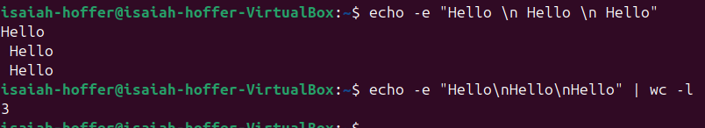

LAB Q B4:



PART C:

LAB Q C1:

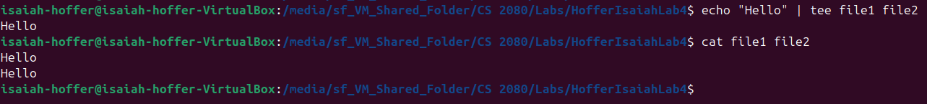

LAB Q C2:



LAB Q C3:

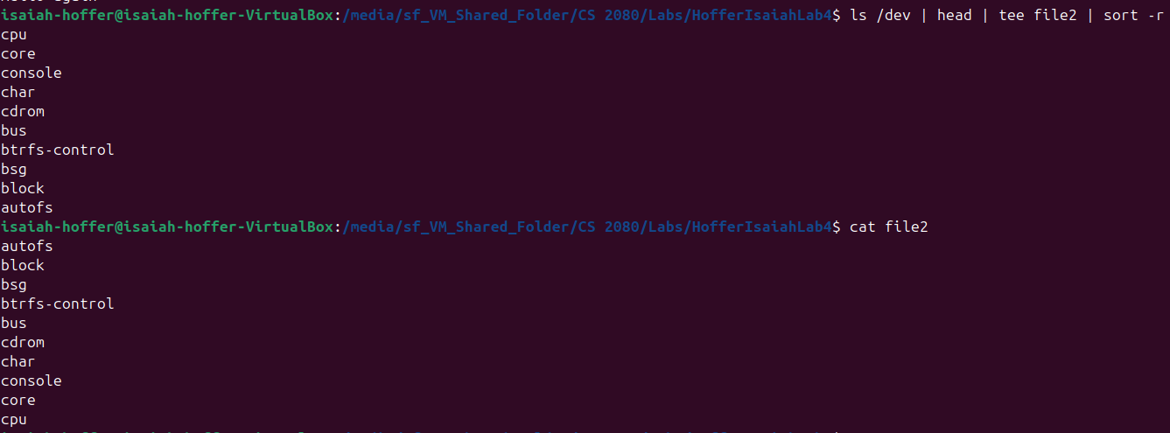

LAB Q C4:

Sort -r reverses the output/result from sort command, does not affect sorting inside of file

PART D:

LAB Q D1:

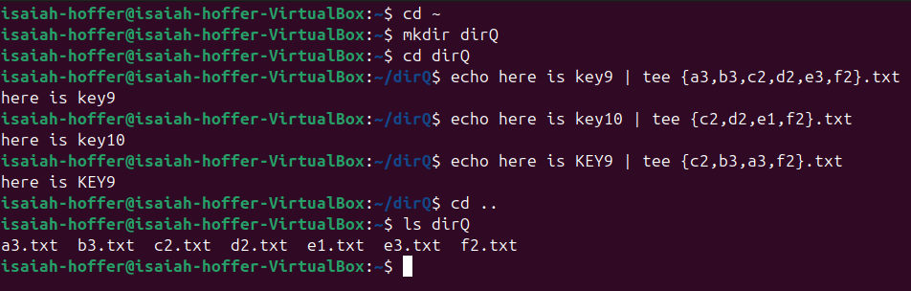

There are a total of 7 files in dirQ

LAB Q D2:



LAB Q D3:



LAB Q D4:



PART F:

LAB Q F1:

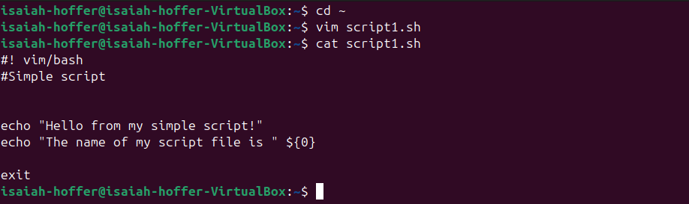

LAB Q F2.1

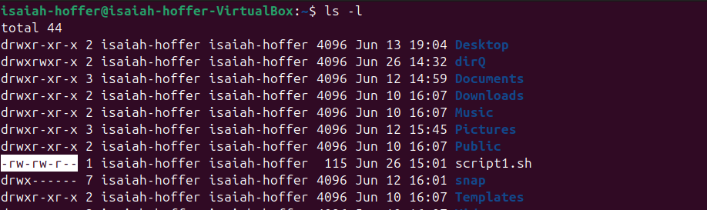

The permissions of the script file for the user is reading and writing, same for group permissions. Everyone else can only read.

LAB Q F3

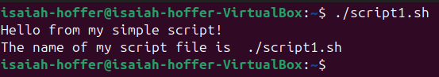

I noticed I made a mistake in the /bin/bash area; I fixed that after the previous screenshot because it errored here.

LAB Q F4:

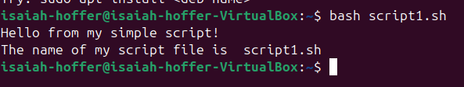

LAB Q F5&6:

The {0} contains the file name white the script is running and after the script is done, it contains the shell name, bash

LAB Q F7:

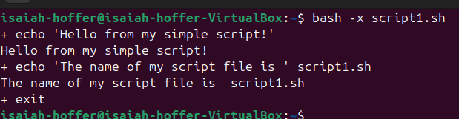

LAB Q F8:

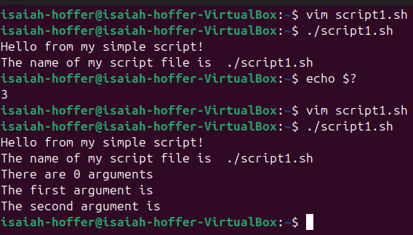

LAB Q F9:

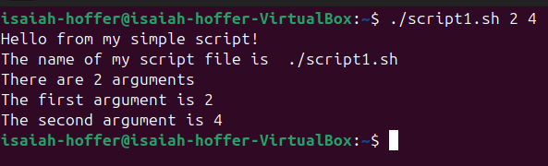

LAB Q F10:

Runing the script file with only one argument will leave the $2 variable blank in the output

LAB Q F11:

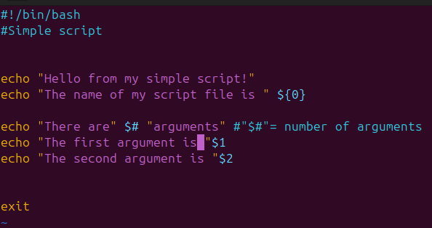

LAB Q F12:

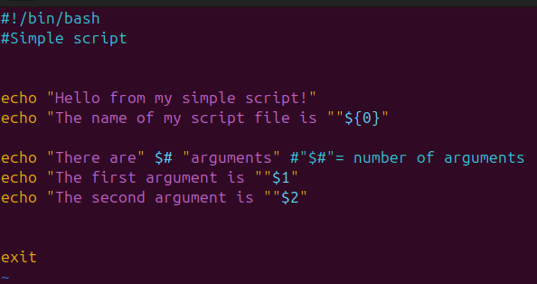

Only change was to add “” around the variables